21236277 Maxwell Maia

1.

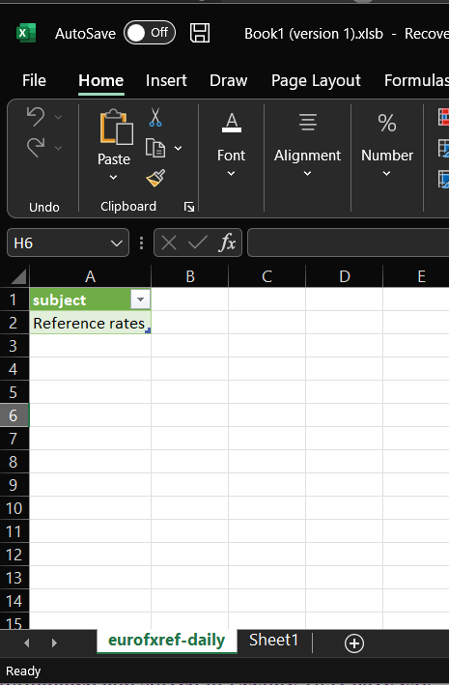

2.

3.

4.